44 West Chesapeake Avenue Towson, Maryland 21204
Phone: 410-825-1144
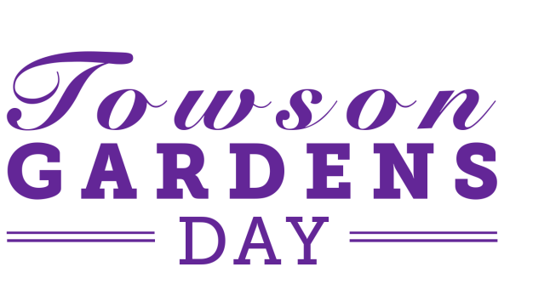
Email: info@towsonchamber.com Web: www.towsonchamber.com

The 35th Annual Towson Gardens Day & Flower Mart will be held on Thursday, May 2th, 2024 from 10 a.m. to 3 p.m. at the Towson Courthouse Fountain Plaza and adjacent West Pennsylvania Avenue, Baltimore Avenue & Washington Avenue.

Please complete the attached application and return it with a check payable to the Towson Chamber. Please note that if the check bounces, it will incur a $50 service fee. Please mail the check and application to:
Towson Gardens Day
Towson Chamber of Commerce
44 W. Chesapeake Avenue Towson, MD 21204

You may also pay via credit card over the phone. Please note that a 3% charge will be added to your total if paying via credit card. In April you will receive a letter that includes your space assignment, set-up time, parking information, and other logistics. Please keep this information as a reference.
Important Information:
- Space size: 10’ x 14’ wide.
- Exhibitors/vendors need to provide their own tables, chairs/booth and power (generator) if needed.
- Tents can be rented for a $100 charge. They will be set up prior to your arrival, and taken down after closing.
- If bringing your own tent, you must have at least 20 lbs. of weight on each leg of the tent.
- Food Vendors Only:
  - Food vendors must obtain a $25 permit from the Baltimore County Health Dept. 6401 York Road, Third Floor, Baltimore, MD 21212-2130
  - Food vendors must be able to show proof of an Annual Food Permit.
    - Questions regarding Food Concessions or Health Department Regulations:
    - please call 410.887.BCHD (2243)

If you have questions, please call the Towson Chamber of Commerce at 410-825-1144
or email: nancy@towsonchamber.com

Indemnification: The exhibitor agrees to indemnify and hold harmless the Towson Chamber of Commerce Inc. and the Towson Gardens Day Committee, their officers, directors, employees and agents from any and all claims including, but not limited to, those based upon property damages, personal injuries, taxes and/or loss, in any way related to the Event including reasonable attorney's fees, unless such loss or injury is directly the result of negligence on the part of. The Towson Chamber of Commerce Inc., and the Towson Gardens Day Committee and their officers, directors, employees and agents assume no liability for loss of or damage to exhibitor's property.

Date:________________________________________ Signature:____________________________________________

Mission Statement: The Towson Chamber of Commerce, Inc. Promotes the Business Environment in Towson

For Office Use Only

Space #

Pd.

Amt.

Thursday, May 2th, 2024
10:00am - 3:00pm

Agency, Company or Organization__________________________________________

Contact Person Phone ______

Email Address:____________________________________________________________
Mailing Address: ________________________________________________________________
Website: _________________________________________________________________

Please indicate the amount of spaces needed next to the appropriate category:
*Each price is per space at 10’x14’
Flowers/Plants ………………………………………………………….$45.00 ______
Arts/Crafts ………………………………………………………………$50.00 ______
Food…………………………………………………………………….. $80.00 ______
Food Truck Dimensions____________ Please Check One: Driver side service ____ Passenger side service ____
Commercial Products…………………………………………………..$200.00 ______
Political Parties & Candidates…………………………………………$200.00 ______
Non-profit organizations………………………………………………. $40.00 ______
Baltimore County Organizations..……………………………………..$0.00 ______
Optional Fees
Tent Rental……………………………………………………………….$100.00 ______

Grand Total………………………………………………………………………_______________
Payment (please check one): Check Credit Card Cash

To avoid duplication of products, please provide a brief description of your product:
______________________________________________________________________________________________________________________________________________________________________________________________________________________________________________________
Towson Chamber of Commerce
44 W. Chesapeake Ave. Towson, MD 21204
410-825-1144
Mission Statement: The Towson Chamber of Commerce, Inc. Promotes the Business Environment in Towson

